What are indicators of winning a game of League of Legends?

End result would be a list like: From most important factors to gameplay luxuries, 1. Gold gain 2. Kills 3. Baron dragons 4. Inhibitors 5. Getting first kill in the game, all of these ranked by a p/t test or something

Could follow up with looking into exceptions, or close exceptions, would that define a “comeback”? But that would probably involve looking into the timeframe of the game.

Data sources: there’s <https://www.kaggle.com/bobbyscience/league-of-legends-diamond-ranked-games-10-min> but only the first 10 minutes of the game are recorded and details logged.

Riotgames Sites:

[https://developer.riotgames.com/docs/portal](https://developer.riotgames.com/docs/portal#product-registration_application-process)

<https://developer.riotgames.com/apis#match-v4>

So my project idea is looking through League of Legends match data to find if certain aspects of the game objectives contribute more towards winning the match. I think I plan to do it solo unless someone wants to join in.

This product is designed for a class project where everyone else besides myself is assumed to have little or no knowledge of League of Legends. "League for New Spectators" would be explaining the basic mechanics and gameplay first, then use statistical analysis of games from different ranks to picture how each rank prioritizes certain tasks, such as kills, gold, barons, inhibitors, etc.

The APIs planned to use are Match-V4,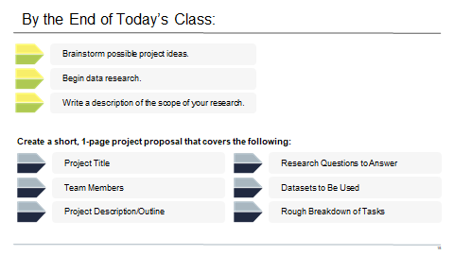

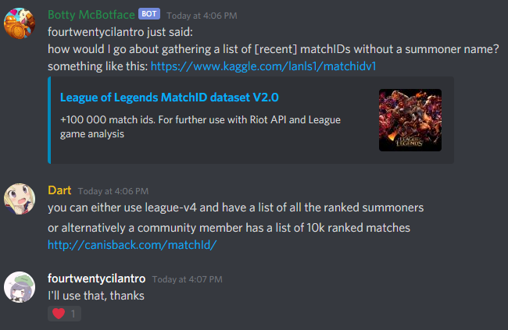

Okay let’s start procrastinating. Note: Begin simple, only use match-v4, go do a timeline extraction with timeline someday else.

God bless. For starters I used region NA1, and this resulted in a list of 10k NA matches.   
<https://developer.riotgames.com/docs/lol>

queueID: as long as it’s ranked

mapID: as long as it’s Summoner’s Rift, which corresponds to mapIDs 1,2,11

gameMode: CLASSIC or out

gameType: The community member pulled only ranked matches, so ranked.

Game data to extract: mostly team data, HOWEVER does not include how many total kills/deaths a team has at the end of the game, so that has to be done through player kill counts

List work. The team stuff is easy enough, but adding up a team’s kills is a different story, likely going to need a for loop.

Graphs: box and whisker graphs for length of game and maybe other factors to sort outliers, and then mostly bar charts to see if there’s standard distributions.

What I didn’t expect: 180 games that were less than 10 minutes, that’s a sign of an early team resignation. So I cut those out and worked with what’s left. 9819 entries total.

|  |  |  |  |  |  |  |  |  |
| --- | --- | --- | --- | --- | --- | --- | --- | --- |
| Boolean | win | firstblood | firsttower | firstinhib | Baron | Dragon | Riftherald |  |
|  |  |  |  |  |  |  |  |  |
| Integer | gameDuration  (only in sec) | Towerkills | Inhib kills | Baron kills | Dragon kills | Rift H kills | Hero kills&deaths | wards |
| Long | gameDuration  (if not in sec) | goldearned | Minionskilled | Avg champ lvl |  |  |  |  |

Gold Difference:

Did graphs and shit, 217 games were won with a negative gold lead.

3388 games were won with killing less minions, 56 equal

558 games were won where the winning team had less than or equal average levels than the losing team

271 games where team won but killed less towers, 220 games where equal number of enemy towers were killed

1726 games were won with teams killing equal number of enemy inhibitors, 246 games won with killing less inhibitors

643 games won w/ killing less barons than opponent, 4404 games won w/ killing equal number of barons

1333 w/ less dragon kills, 1182 w/ equal

2504 w/ less rift herald, 2094 w/ equal

573 games where the winning team killed less heroes than other side, 123 where kills are equal

9118 games w/ less deaths than losing team, 122 games w/ equal number

3700 games won w/ less wards placed, 375 equal

3444 w/ less ward kills, 872 w/ equal

5787 games won w/ first blood won

7006 games won w/ first tower

7700 games won w/ first inhibitor

4886 won w/ first baron, 6205 w/ first dragon, 5785 w/ first rift herald

Average Length of games: 1753 seconds



Conclusion:

Having a gold lead is by far the best indicator of winning a League of Legends match, which is a game value that lasts throughout the game.

Of the “first” Boolean values, first inhibitor tends most to winning the game, followed by first tower, dragon, first blood, rift herald, and lastly baron.

Overall, having more hero kills and tower kills wins the game, having less inhibitor kills and tower kills than the other team strongly indicates losing a game, baron kills affect the game the least.

Things I would have done if I had more time: do more analysis with conditions such as number of winning teams meeting more than one objective, or teams that won without getting certain objectives or first kills.